LUCKY WHEEL

Mobile Development – Milestone 1

# **Project Details**

|  |  |
| --- | --- |
| **Project Name** | Lucky Wheel |
| **Sensor’s Used** | Accelerometer |
| **Firebase Services** | Authentication (email and password), Real-time Database |
| **Data Preferences** | Data Store (preference) |
| **Fonts (Google Fonts)** | Inter, Knewave, Merienda, Space Grotesk |

# Main Goal

Lucky Wheel is an gaming app. The main goal of the app is to have an competitive game play for collecting the golds by spinning a wheel. The spinning wheel will land the pointer on a random choice (arch) on the spinning wheel. The player can earn or loose gold, by spinning the lucky wheel. The app shows Realtime data ranking on for players with high gold count.

# Layout’s

# Design

## Authentication Screens

The app allows new user to register using their name, email, and a password. The existing user could login. Once the player logged the login info will be stored in data store, as a preference, So next time when the user comes back after a pause or closing app, the app will still logged in.

Both the login and register text field are sanitised and validated before authorization. Any validation error will displayed as toast on bottom.

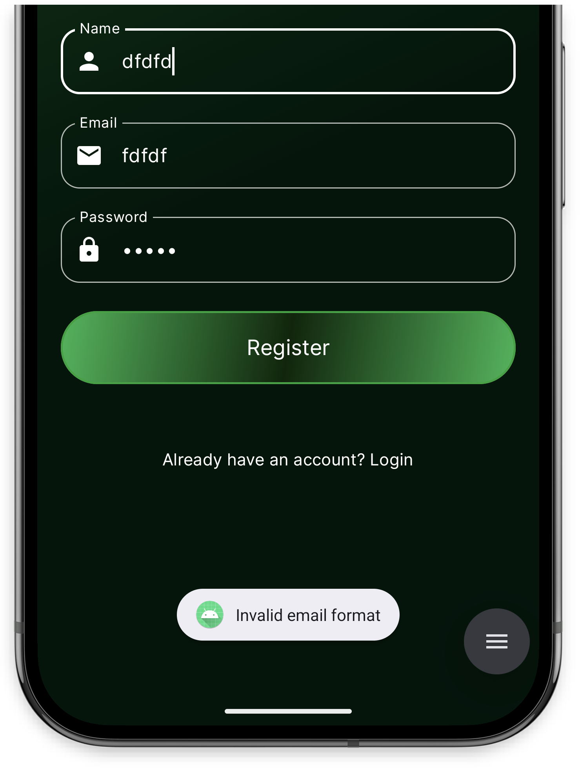

## Playground Screens

Inside the playground the player could switch between the gold game and the custom player spinning wheel game.

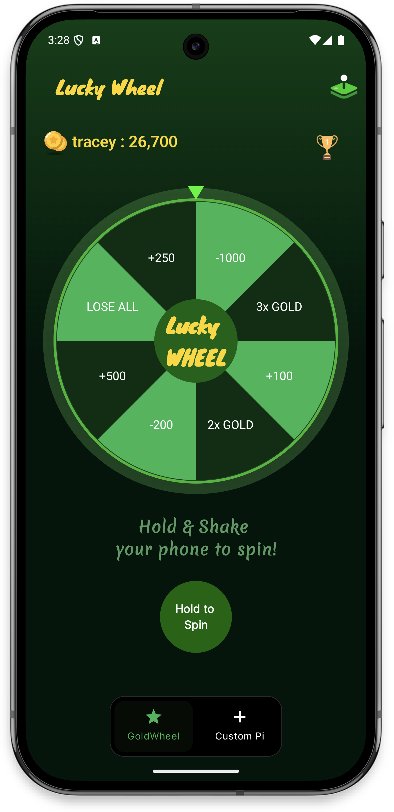 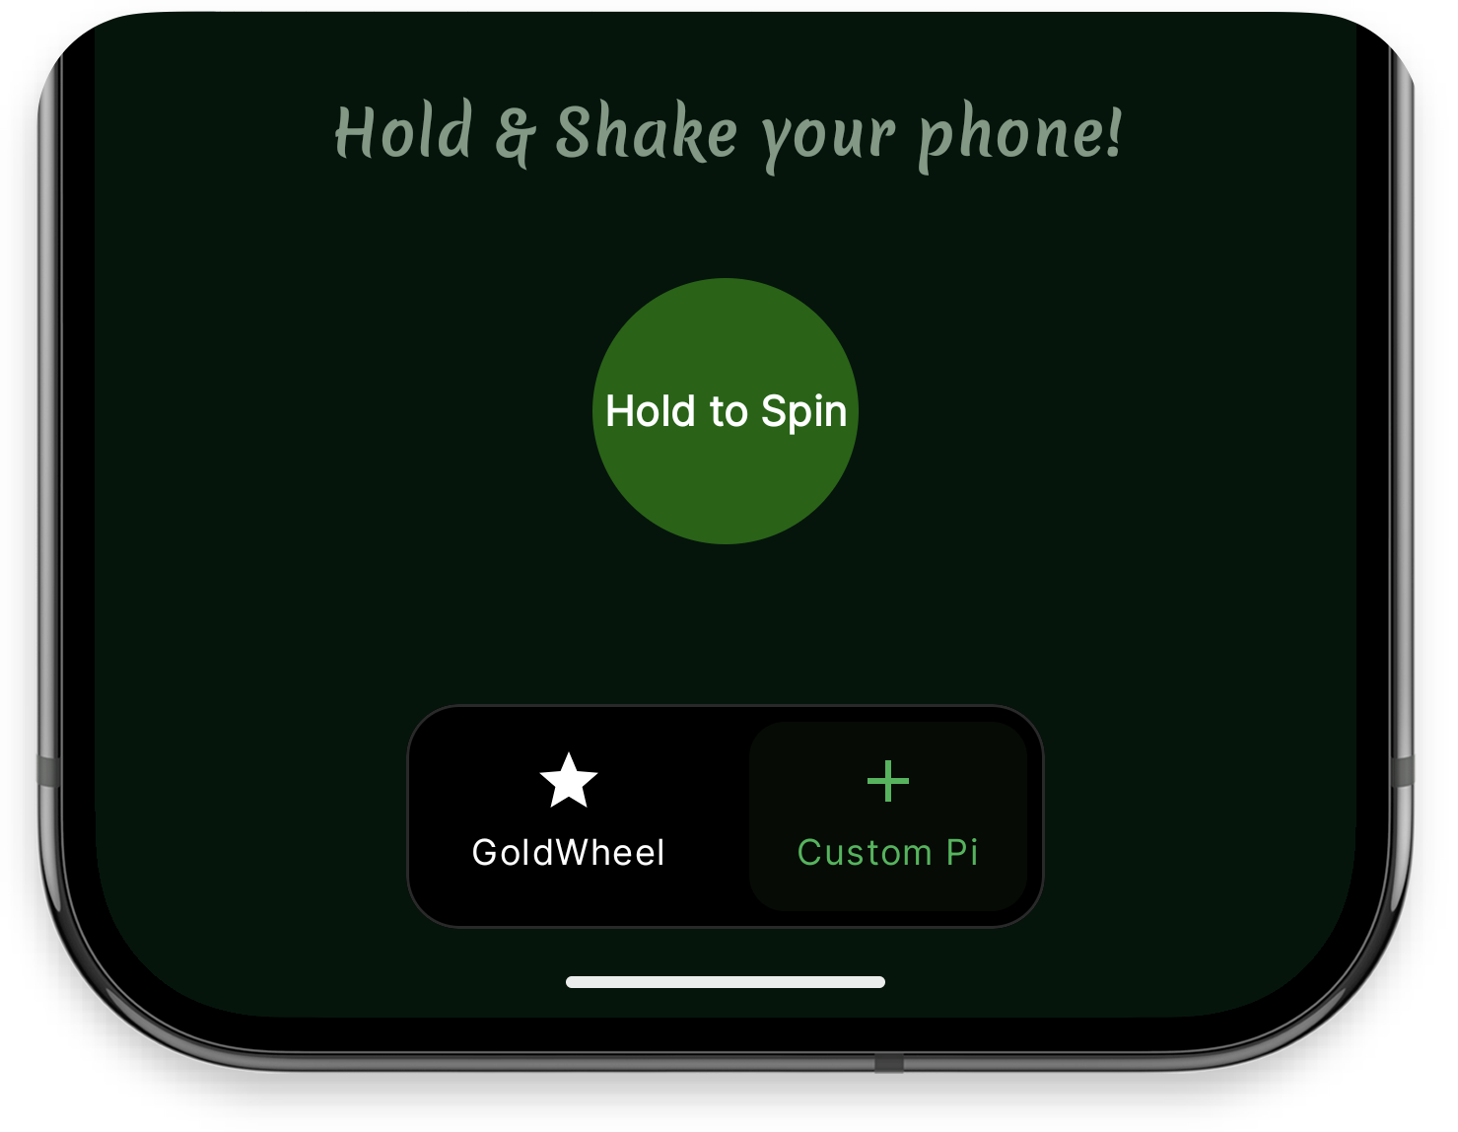 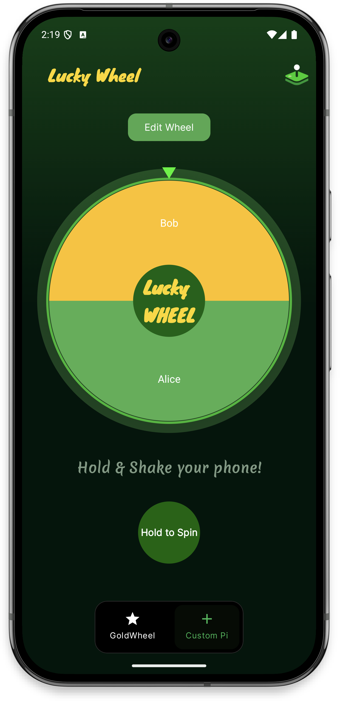

### Gold Wheel Section

Player spin the lucky gold wheel by pressing and holding the green bottom button and shake to spin the wheel. The spinning result shows as soon as the wheel stops as a pop up window.

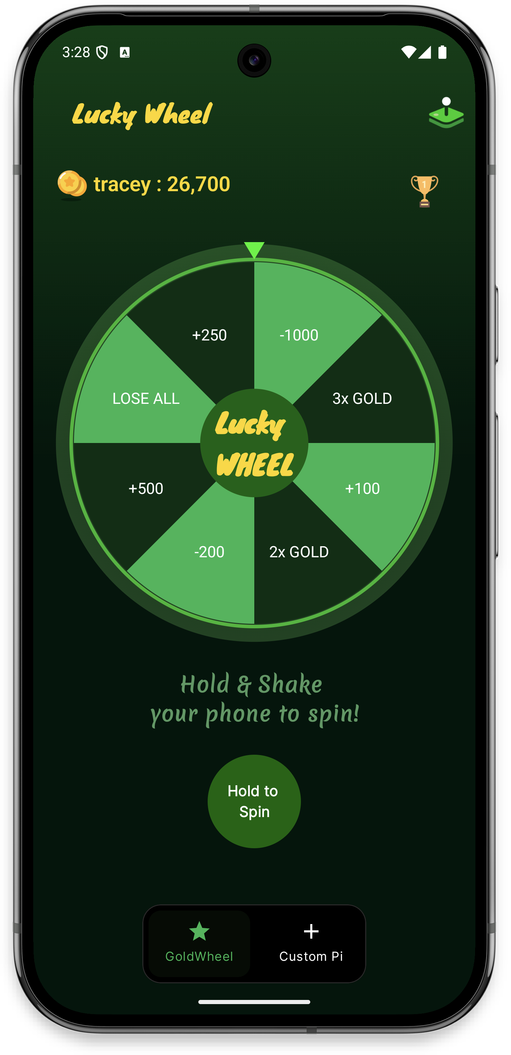 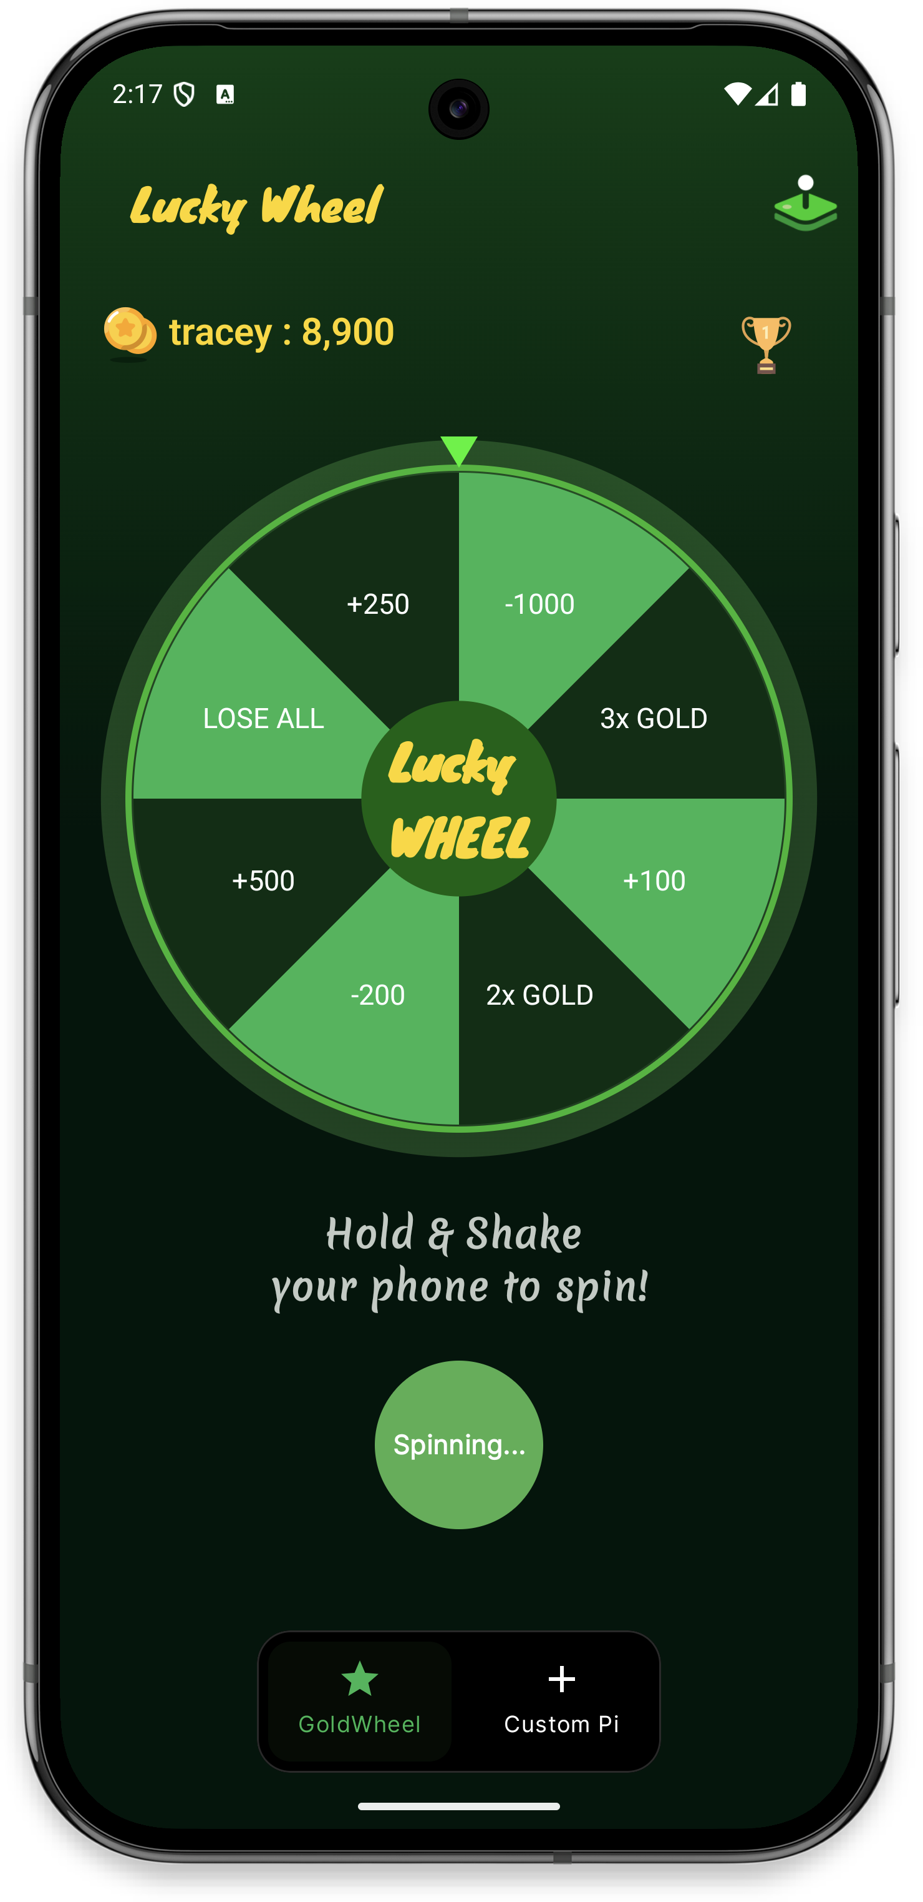 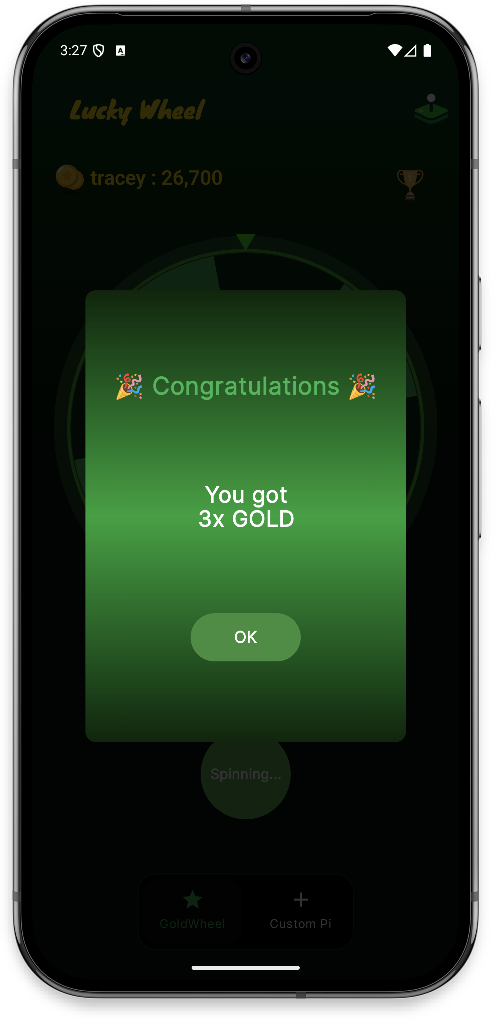 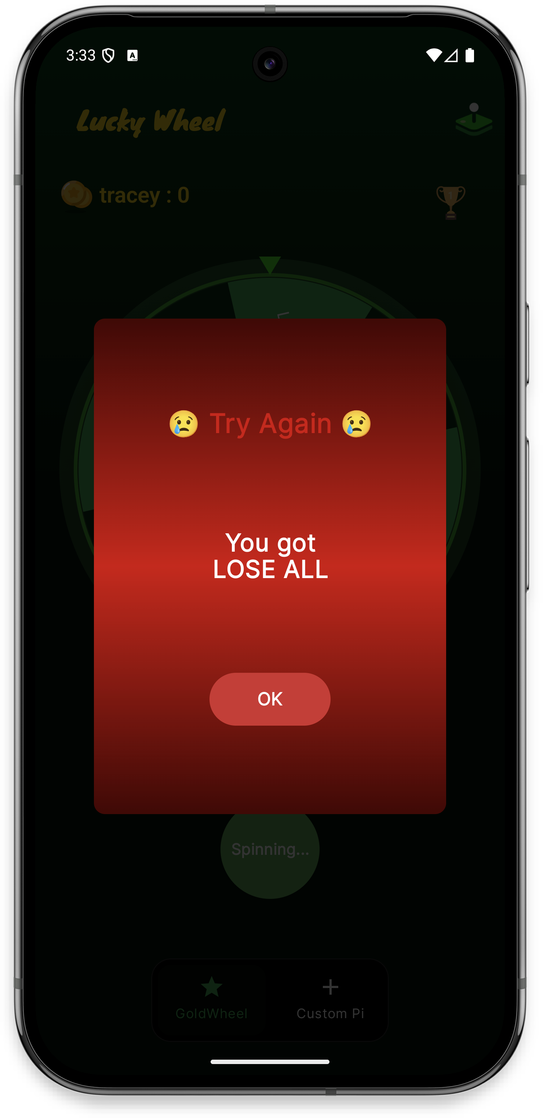

### Custom Pi Section

Player can use the same press and shake feature, to spin the user customizable wheel.

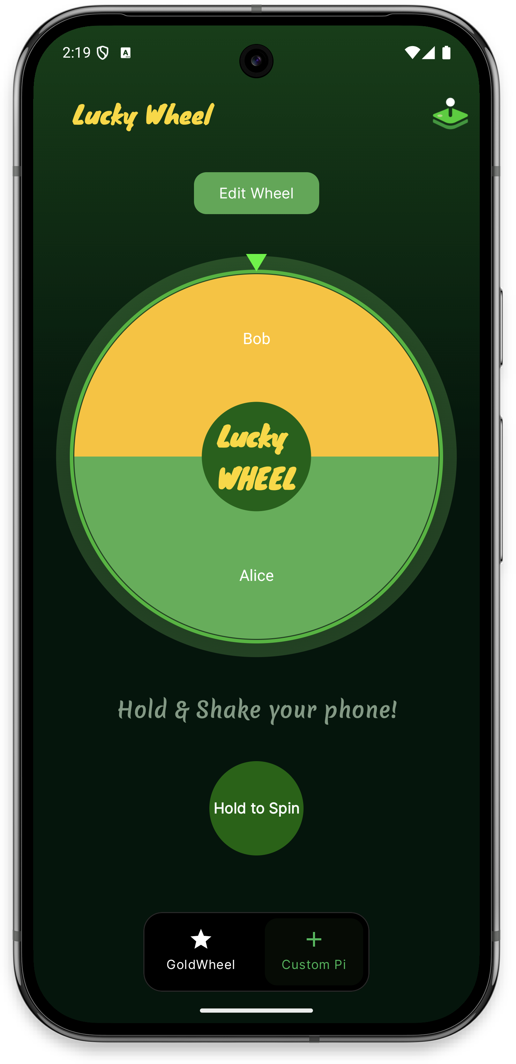 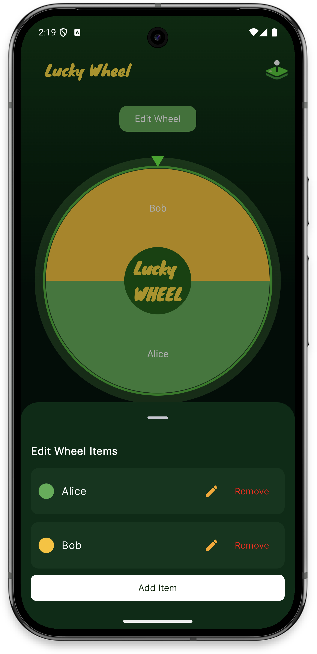

On clicking “**Edit Wheel**” button, user can add new item to pie and adjust the percentage of pie sharing. The user can also rename the label, edit the color. If needed user can also remove the item from the pie.

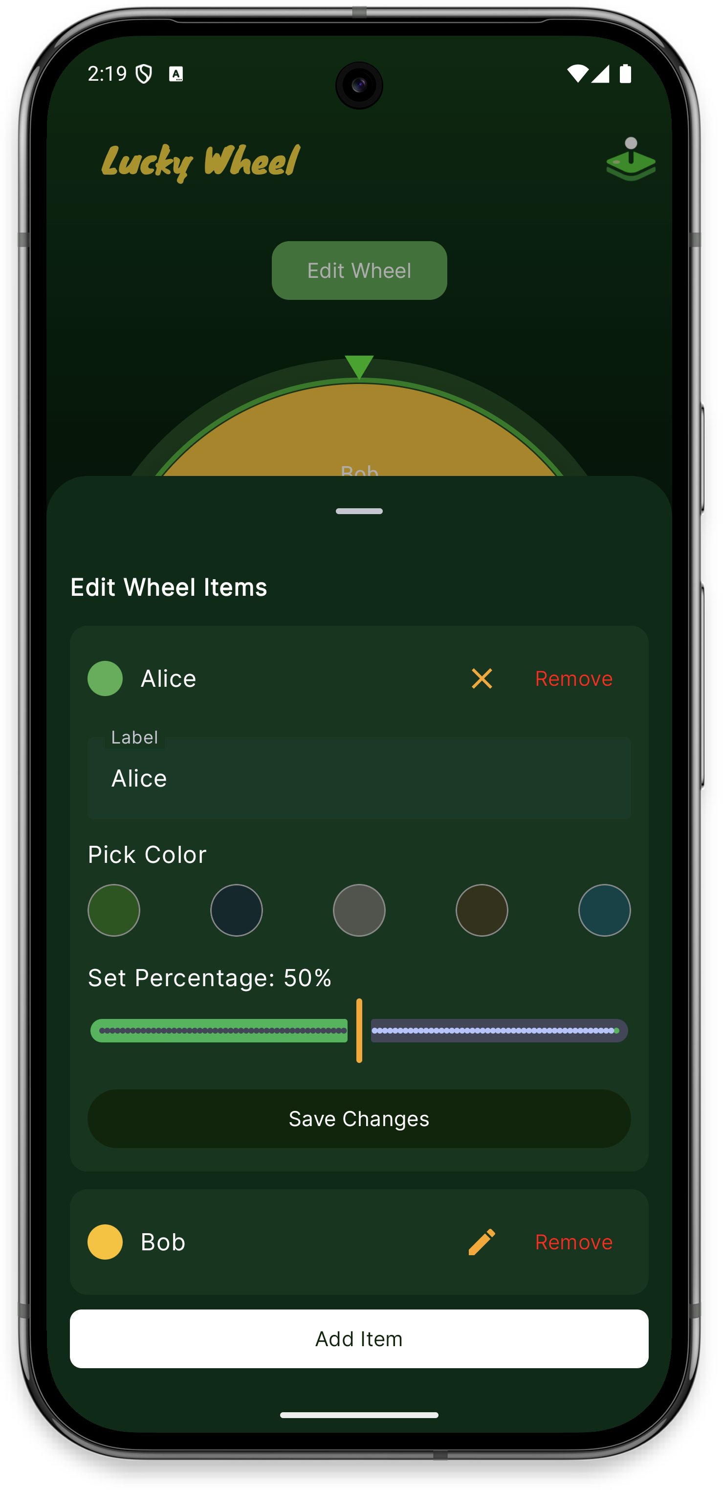 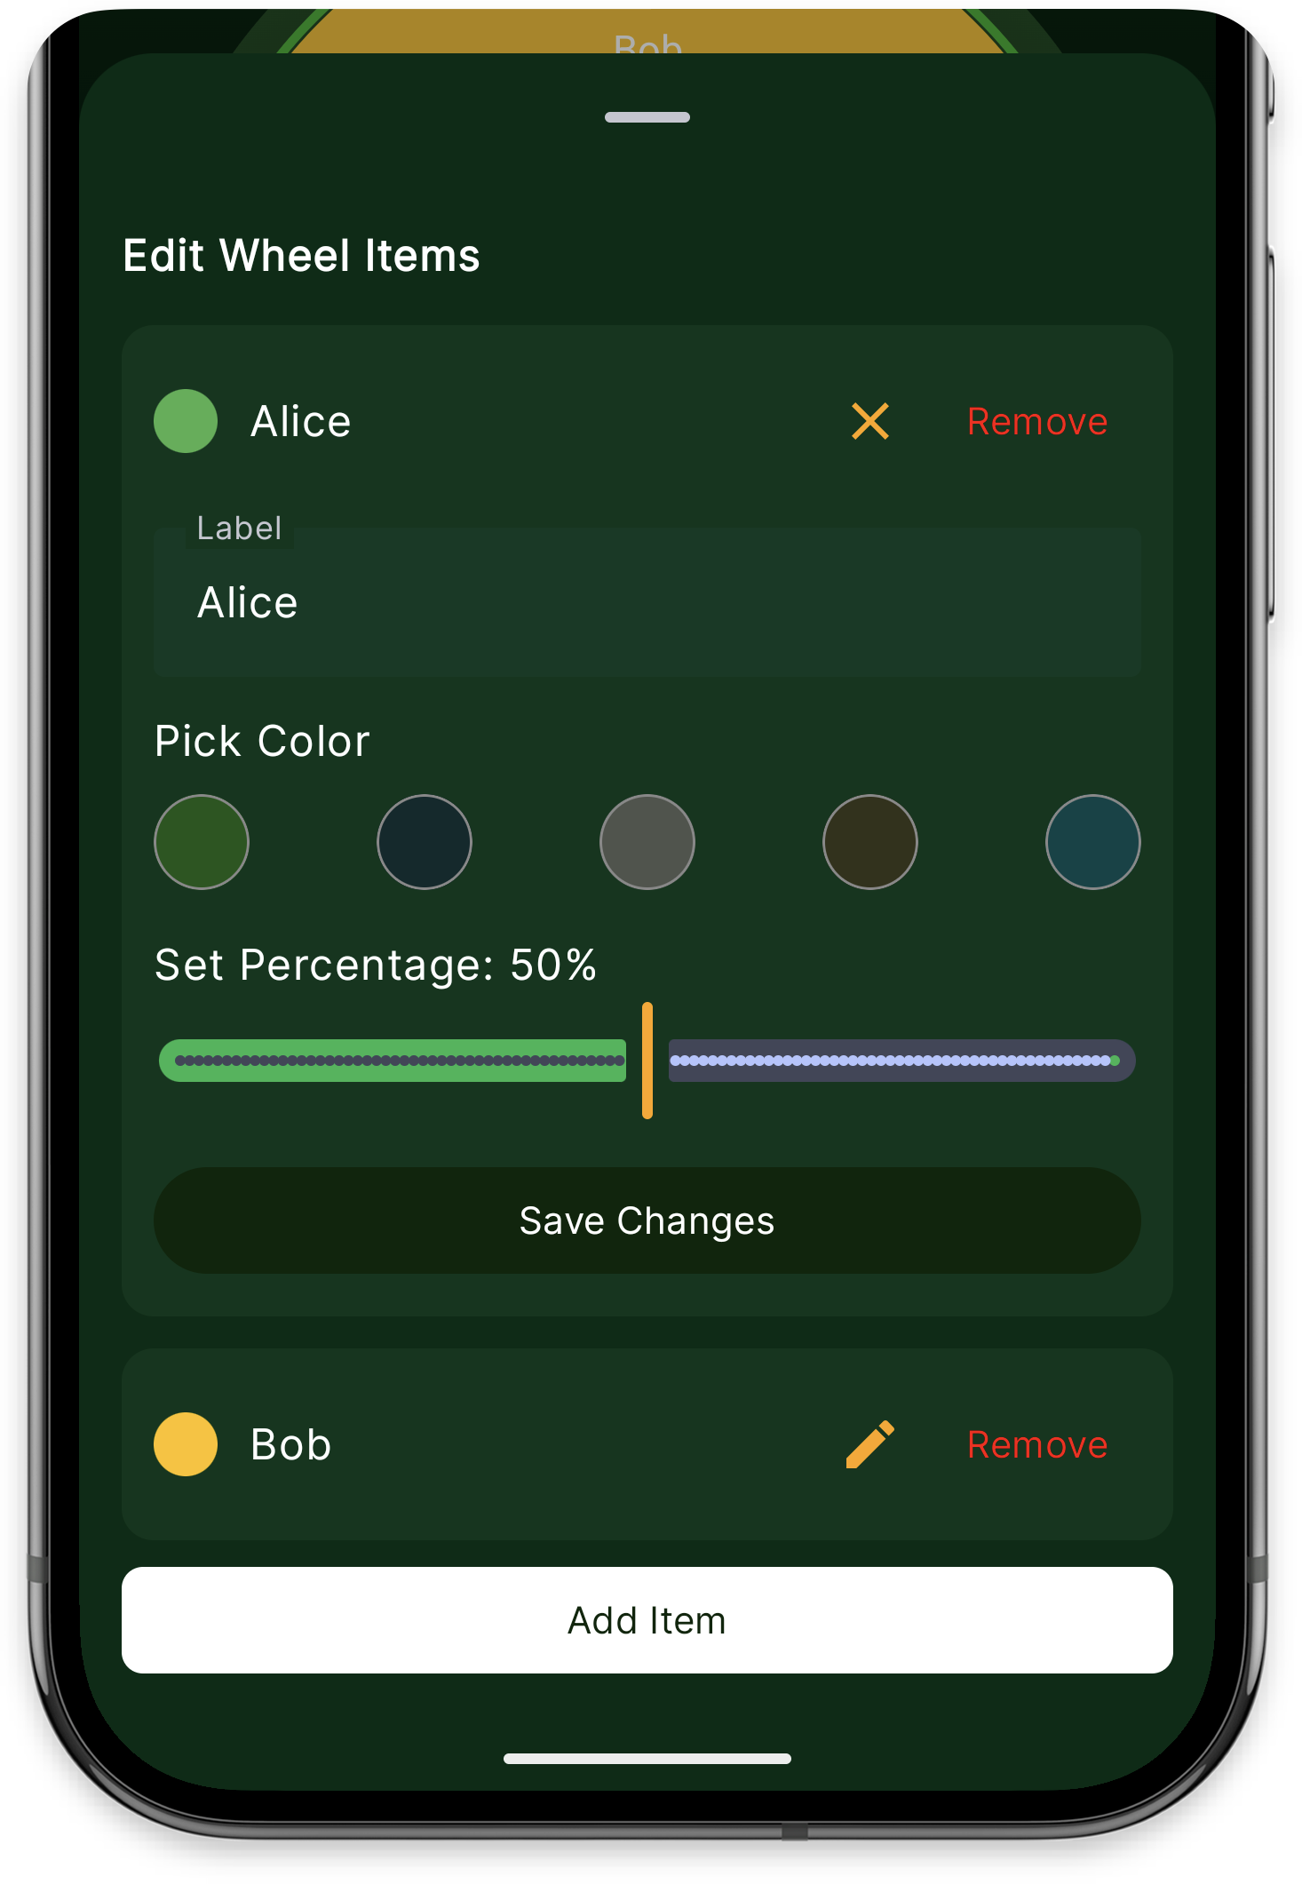 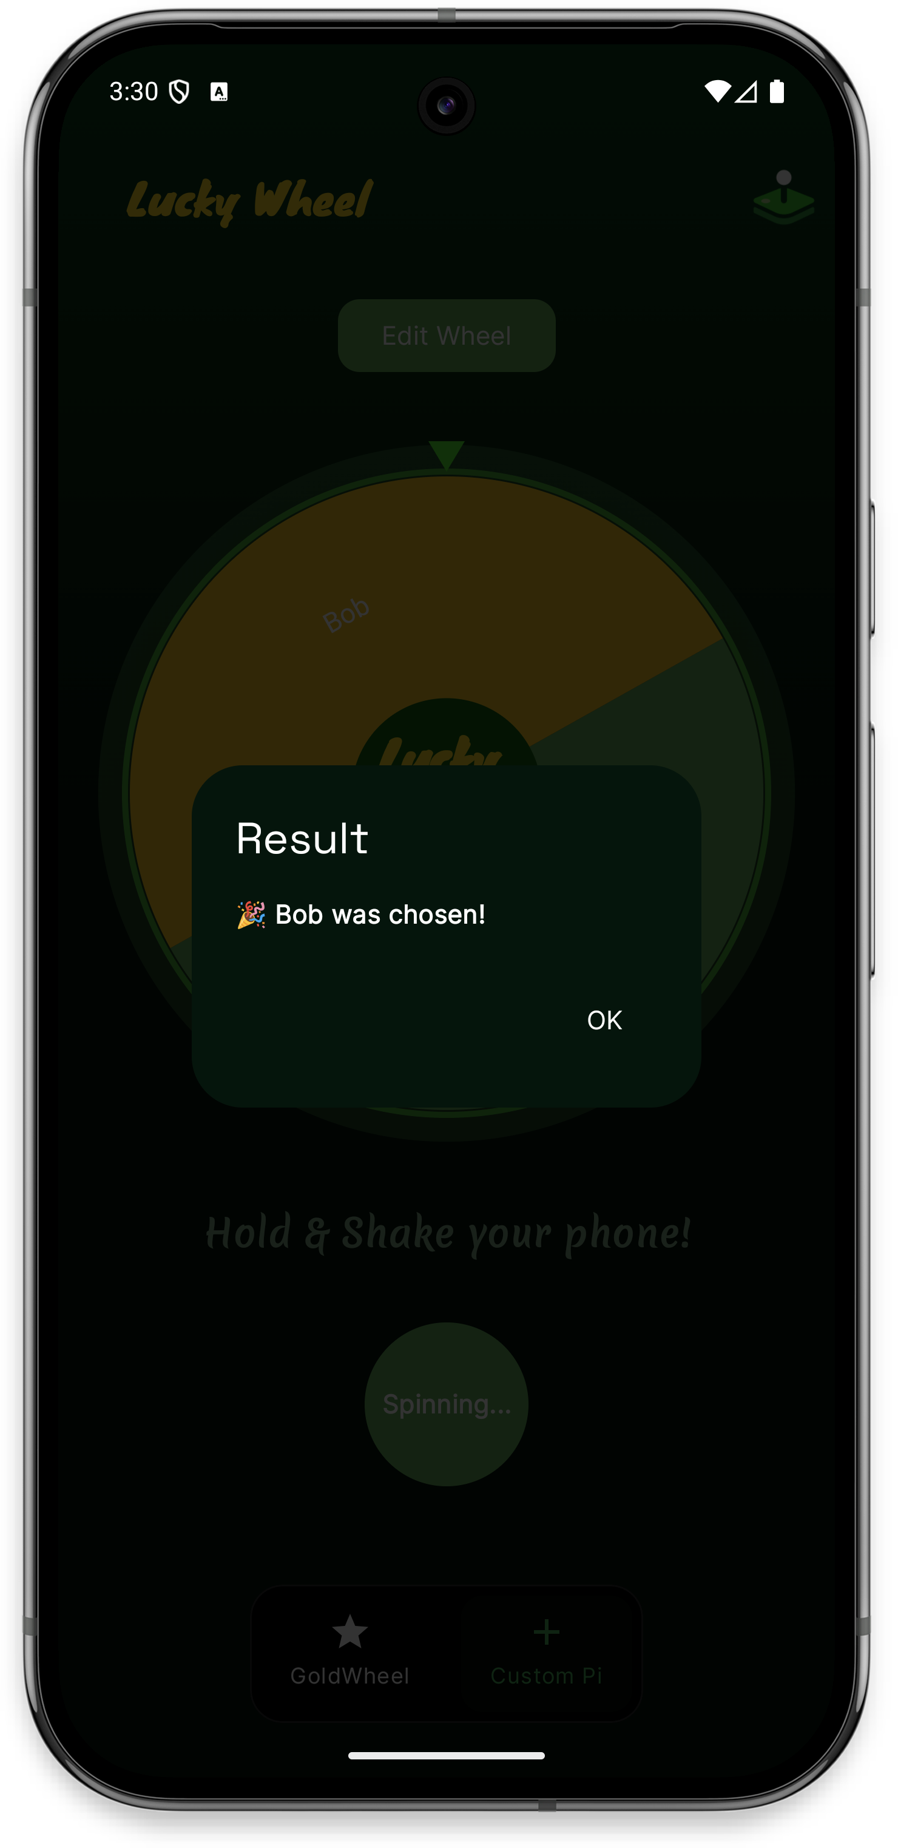

## LeaderBoard Screen

Players can view the top ranked players on clicking the trophy icon.

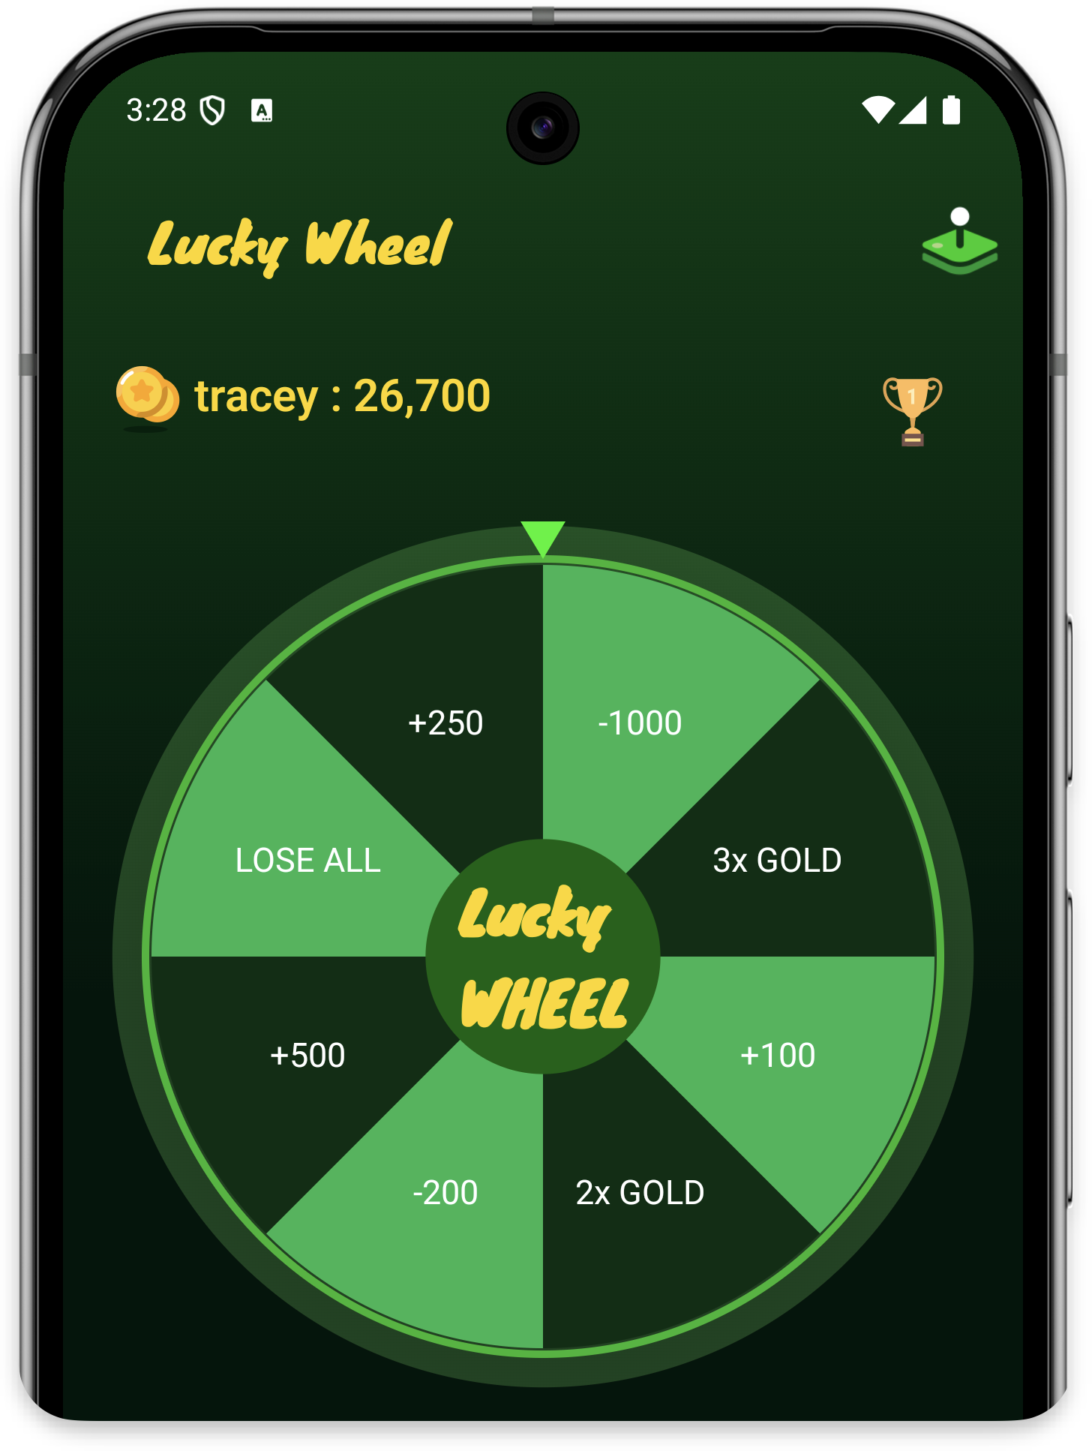 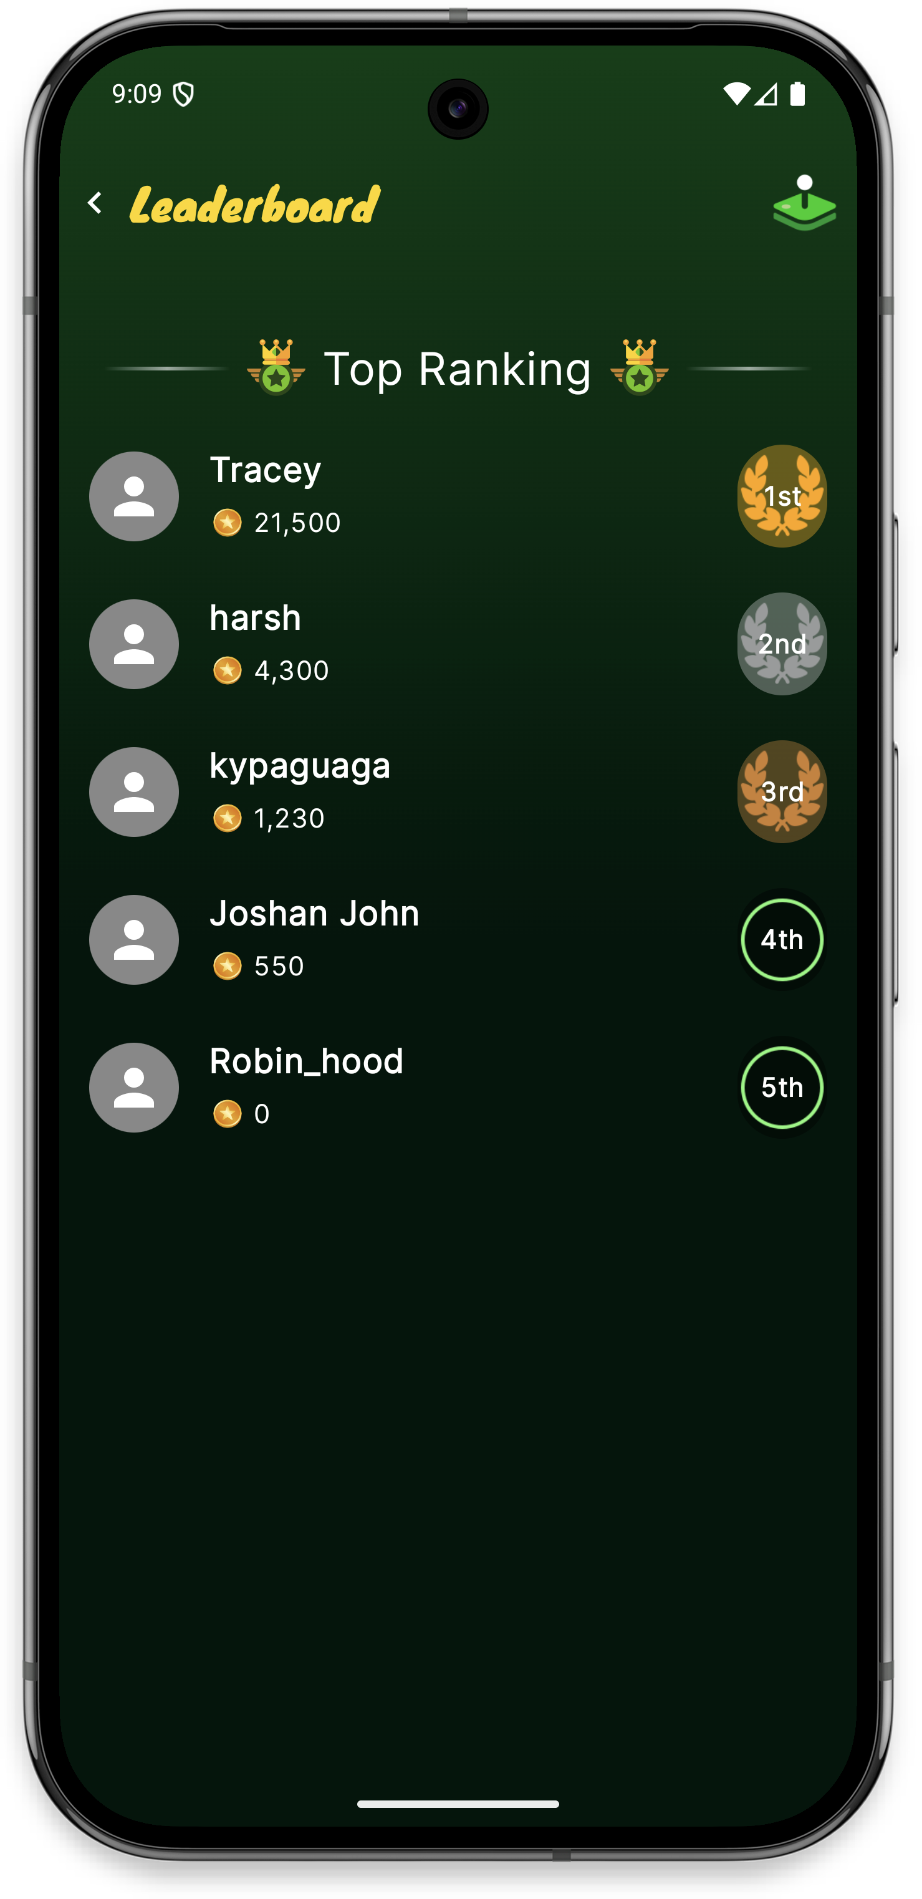

Layouts

Design pattern

Why choosing m m this design

# Sensor Formulas